A CHRONICLE OF EARLY IPPEL HISTORY

Dieter Ippel, (for information on Dieter's ancestors, see addendum) born September 4, 1797, was a wealthy farmer, holding much land in North Brabant, the Netherlands. Upon his death, he divided his farm amongst his sons and gave a cash settlement to his daughters. A family story refers to grandfather's money chest in which the money was kept. It was quite a ritual when the "groote kist" (large chest) was opened for payment of bills, etc

Because the farms given to the sons were actually too small to make a good living and because Hendrikus. his son, had numerous sons to whom his inheritance would have to be divided, he decided to emigrate to America. Prior to emigration he was already renting other land besides his dairy farm near Werkendam. Yet economic conditions seemed to have thwarted him in providing a "good living." Their decision to leave Werkendam was greeted with little enthusiasm by their relatives and neighbors even though Hendrikus brother, Gerrit, had previously emigrated to the Pella, Iowa area. The onlookers as they left to board the train to Rotterdam thought their desire to better themselves did not require such a sacrifice as a venture to a land of "bears, lions and Indians." Evidently Werkendammers knew little of America or what they knew was not enticing for not a large number of them emigrated at that time. Among those who had left Werkendam•to America, however, was Hendrikus brother-in-law, Wouter De Graaff, born 26 January 1826, died 6 May 1912, who emigrated from Rotterdam to South Holland, Illinois, on 26 May 1856 on the ship "Espaminondas". Wouter was a brick mason. Wouter's brothers, Jan and Bastiaan, also preceded the Ippels.

Hendrikus was known, however, as a good farmer and a good provider, although not as churchman. He was a member of the Nederlandsche Hevormde Kerk, the state church, and not well instructed in the Bible or theologically conversant. His wife, Elizabeth De Graaff, was a member of the Christian Reformed Church, more devout and pious. Three of her brothers had preceded the Ippels to America and settled in South Holland. Bastian De Graaff born 11 August 1859, died 30 March 1939 owned and operated a grocery and dry goods store in South Holland. He was evidently interested in religious matters. He possessed Calvin's “Institutes” and read much from Brachel, an eminent Dutch Reformed theologian. Jan De Graaff, born in 1839 and died in 1907 was involved in politics in Harvey, Illinois.

He was self-educated, conversant in several languages, and a supervisor in the Austin Iron Works which produced railway locomotives. Although the Iron Works sent him to an "institute" to correct his alcoholism, he apparently lost his position due to his "problem". Wouter De Graaff (already mentioned) was not a religious person. He was a large landowner in the heart of South Holland possessing much of the area south and east of 152nd and Chicago Avenue.

Hendrikus and Elizabeth (De Graaff) Ippel, six sons: Pieter, Jan, Marten, Adrianus, Bastian, and Cornelis, and two daughters, Hattie and Bastiannus, left Werkendam for America on January 10, 1893 on the S.S.Werkendam. The voyage was exceedingly stormy. Cornelis, born June 21, 1892, was less than a year old and experienced serious convulsions on the journey; he was not expected to live but the ship's physician suggested immersing him successively in hot and cold tubs of water. He survived!

The original intent of the Ippel family had been to join the Gerrit Ippels in the Pella, Iowa area but they were drawn to South Holland because of the previous settlement there of the De Graaff brothers and perhaps other relatives of the De Graaffs (perhaps the Van Drunens).

Hendrikus originally rented a farm from one of the De Graaff relatives. He soon discovered that the land was poor, the machinery in bad shape, the cows poor milkers. Adrianus (Andrew) often said: "They took us for greenhorns." Perhaps more colloquially, they were "taken for a ride." Consequently the Ippels moved to 147th Street which was considered Dolton, outside of South Holland where he rented a 30 acre farm from a Jan Verhoeven for a yearly rent which he paid in silver dollars!

Life on the 147th Street farm was far from pleasant.
Rather than have a dairy farm, the Ippels now entered into green produce farming - vegetables of all sorts -onions, cucumbers, corn etc. with a family of boys, considerable work could be done. The land was made especially fertile by the acquisition from the livery stables of Chicago of large quantities of horse manure. The stables were unable to store the huge quantities of manure in the city due to odor, etc., and thus they loaded it in box cars and shipped it out of the city. That which came to Harvey was transported to the Ippel farm. However, this fertilizer carried with it an abundance of weed seeds. Consequently the major task of the Ippel sons was the backbreaking weeding of onions, the picking of vegetables, etc. Cornelis said that the weeds grew so fast that when they ended one row of weeding and turned around they could see the weeds

cropping out at the beginning! (Is this the origin of the weak backs among the Ippels?) Andrew, however, was free from much of this work because he was assigned to "peddle" or sell the produce house to house in Harvey and Blue Island (neighboring communities) as well as to take wagon loads of produce into the Chicago Market.

Life in Dolton was not easy either because of the constant harassment the Ippel boys received from the youth of South Holland where the Ippels attended church services and catechism. Evidently there was little love lost between the two adjascent communities. Dolton evidently had an unsavory reputation and the South Hollanders looked down upon Dolton residents from "across the tracks". Consequently the Ippel sons were frequently beaten up or threatened by the "bullies of the South Holland First Christian Reformed Church." This must have been especially the experience of Andrew, Bastian and Cornelis. Bastian was not one to look upon this treatment with favor and he was known to return such treatment in kind. Evidently he in turn had beaten up some molesters and they in turn set a dog after Bastian and Cornelis while on their way to catechism. Bastian turned on the dog with sticks and stones. Hendrikus met his two sons at the church with his horse and buggy and on the return
trip home he was stopped by the beleagered dog's master, a neighboring farmer, who protested at Bastian's behaviour. Hendrikus stopped his buggy and vigorously informed the protester that if he valued his life 'at all he would immediately return to his farmhouse. The irenic Ippel has-been raised to the flashpoint! On several occasions, Andrew, who had become so presumptious as to attempt to date a girl in South Holland, was beaten up as well. Uncle Cornelis remembers Andrew returning from South Holland bloódied about the head from one of these confrontations.

With such experiences in the South Holland area, it is not surprising that the Ippels began to show interest in Sheboygan, Wisconsin. Evidently the DeGraafs had a relative 'in Sheboygan named De Groot. Sometime before 1903, the De Groots invited Martin and Andrew to visit them. They returned to Dolton with tall tales of the good life in Wisconsin (good farm land), a farm for sale, cows which gave much milk, and an available market. Uncle John did not want to go to Sheboygan; he preferred Pella. Nonetheless he and father Hendrikus went to look over the farm and in 1904 the entire family, except Pieter who stayed on the 147th street farm (and also except the daughter, Bastiannus, who died in South Holland in 1900) moved to Sheboygan. Here they purchased a 100 acre farm including buildings, machinery, 14 milk cows, three horses, "lock, stock and barrel" for $10,000; Hendrikus paid down $5000 which he had saved in the Pullman, Illinois bank. He was known as a richman among the Dutch in Sheboygan. The farm was on the Townline Road, north of Sheboygan.

One source of irritation and concern for the Ippel family was the fact that the oldest daughter and sister, Elizabeth (married to Johannes Brienen) did not emigrate to America. Her mother wrote pleadingly for them to come and on several occasions even forwarded steamship passage money and tickets, but to no avail. In fact, John was sent back to Werkendam for the ostensible purpose of persuading Elizabeth and her husband to come to America. His persuasion seemed to have some effect and he thought they had agreed, until one evening while John was sitting in the kitchen at the home of his sister, Elizabeth emerged from the bedroom crying with the information that Johannes adamantly refused to go to America, once again the spector of "bears and lions" stood in the way. Elizabeth never came to America and none of the Ippels ever returned to the Netherlands to visit them again.

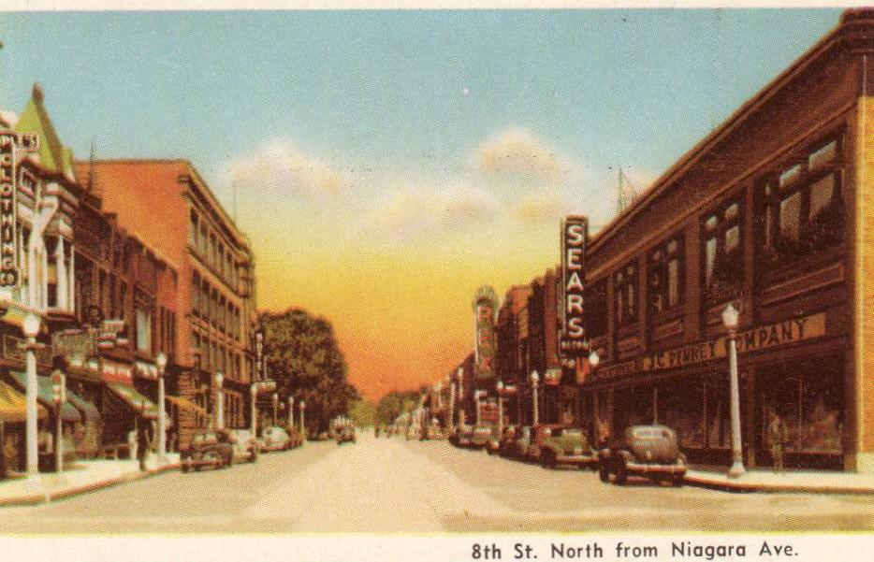
The Ippels quickly adapted their lives to Sheboygan. The church community here was more cordial than South Holland; certainly no sticks and stones and they were impressed by the piety of the people in the Sheboygan Christian Reformed Church. Soon after arrival in Sheboygan, Andrew met Mary Van Stelle whom he began to court. Although the rest of the family did not always return to Sheboygan (a distance of five miles) for the Sunday evening service, Andrew did; sometimes returning home from his "date" after midnite. Consequently the next morning at 4 AM he could not awaken. That was the time the family rose to milk the cows and get them out to pasture. Particularly in the summer it was important to get the cows to pasture early so they could feed on the grass before searching for shelter from the hot sun amongst the trees of the woods where grass was not so abundant. Hendrikus owned his cows to produce milk and not to lazy around under the trees! Martin and Corneal were often in the fields before 7AM when they heard the factory whistles in Sheboygan proclaiming the beginning of the work day. Martin would say: "We've already put in half a day!" Andrew quickly found a job at the Phoenix Chair Company in the city to which he trudged back and forth after doing some of the chores on the farm. The farm had many hands: father Hendrikus, Martin, John, Bastian and Corneal. Hattie helped mother Elizabeth in the house. It was a good farm, but the ippels had to learn to farm the American style. To learn this they read farm journals; Martin especially searched for information and techniques. The farm was diversified: cows (milk) , chickens (eggs and meat); hogs (meat), vegetables and especially beans for the canning factory.

The trek to Sheboygan was normally by horse and buggy, although the young men walked to and from church, to and from work along the railroad tracks.The Chicago
Northwestern Railroad ran north from Sheboygan to Manitowoc between their farm and Highway 141; the trains could be seen from the farmhouse. Their farm was less than a mile from Lake Michigan which afforded a place for swimming and about three miles from Pigeon River which was good for fishing and swimming also. Andrew bought a bicycle but it did not have fenders and thus the clothing of the rider was frequently soiled from the muddy roads.

After arrival in Sheboygan, the Christian Reformed
preacher, Rev. H. Huizingh, encouraged Hendrikus to make a profession of his faith. He had been reluctant to do so previously because he felt insufficiently acquainted with Scripture and doctrine. He feared to present himself to the formidable consistory for this purpose. However at the age of 65 he became a confessing member of the Sheboygan Christian Reformed Congregation.

Bastiaan and Corneal were enrolled in the Sheboygan Christian School. Their first teacher was Mr. De Koning, educated in the Netherlands, unable to speak the English language fluently. Most of the instruction was in Dutch. De Koning had one English language history of America from which he read persistently but with difficulty. when he mispronounced words too astrociously, Bastiaan would tentatively raise his hand and offer a correction. After he had done this several times to the chagrin and mortification of DeKoning, Bastian was told (in Dutch) to mind his own business and refrain from this assistance!

(Another "chapter" in this story will, we hope, follow the history of my father, Andrew and his family.)

ADDENDUM I

Our common ancestor, Bastiaen Cornelisse (b. circa 1620) and his wife, Joostje Hermense (b. circa 1630) seem to have had four children, beside Cornelis (b. 1653) and Pietertje (b. circa 1656), namely Dingetje and Maritje (twins. b. 1658), Hermen (b.1661) and Joris (b. 1665). The mother of Bastiaen Cornelisse was Dinghentjen Joris. Her husband, Cornelis (b. circa 1595) died sometime before 1632, because his wife Dinghentjen on October 9, 1633 as a widow was married in Sleeuwijk to Peter Joosten and then moved to Werkendam. To this marriage another child was born on January 14, 1635 named Maijken.

Some information on the origin of the name "IPPEL":
A purchase-deed indicates that Cornelis Bastiaense (b.1653) in 1686 purchased a piece of land in Sleeuwijk (near Werkendam in North Brabant) from a wine dealer in Rotterdam. The buyer referred to therein is Cornelis Bastianse van Ippel. This, as far as we know, is the first written reference to our family name. The acknowledgement of indebtedness accompanying the purchase-deed contains the name again as Cornelis Bastyaense van Ippel but he himself signed as Cornelis Bastijanse. Among the many documents which Cornelis later signed in Sleeuwijk as sheriff (law enforcer) he added to the name Cornelis Bastijanse the word Ippel (not van Ippel). His oldest son, Jan, later as sheriff of De Werken, followed this custom. He signed as Jan Cornelisse Ippel. This is the origin of our present family name.

In a document which is the first instrument Cornelis (b. 1653 signed as sheriff of Sleeuwijk (he held the office for almost 30 years) it is striking that he is referred to as Cornelis Bastiaense "van Ippel" but has signed it Ippel. The words Uppel and ippel are used interchangeably. Uppel was the name of the polder where Cornelis (b. 1653) or his father had lived. Most likely the word Uppel was pronounced Ippel.

ADDENDUM II

In 1919 komt Sebastian (Bastian) Ippel uit Sheboygan, over zee, om tijdens de eerste wereldoorlog. Zijn naam staat vermeld op een gedenksteen met de gevallenen uit die oorlog. (1892 > 22-04-1919)
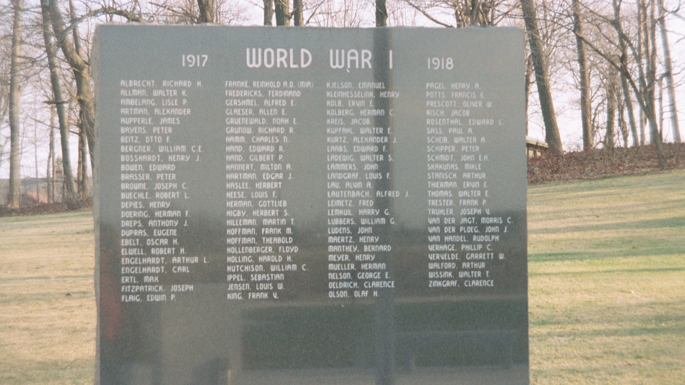
In de bibliotheek van het Calvin College te Sheboygan, Wisconsin USA: “The Ippel Ancestral Home, A History of the Farmhouse Built in 1737”.
De amerikaanse Ippel-tak is door de jaren heen met de Christelijk Gereformeerde Kerk verbonden gebleven. Het volgende als recenten illustratie hiervan.

Miriam Ippel Junior.
Afgestudeerd aan het Western Theological Seminary (Michigan).

I was born into a Christian family, and part of our journey was spending six years in Liberia, West Africa serving through the Christian Reformed World Relief Committee. Those formative years (ages 4-10) shaped me in countless ways. I am grateful for many opportunities to travel throughout the world as a child and as an adult. Meeting Christians and non-Christians in different cultures has spurred me on in my faith, challenging me to radical discipleship. Since 1999 I have been serving the Lord in various campus ministry positions. My journey to seminary has been guided by life experiences, my family, friends, and church communities, and God’s call on my heart. It is an amazing gift to be here.

